American Legion Post 37 – Memorial Brick Order Form 

|  |  |  |  |
| --- | --- | --- | --- |
| Name: |  | Email: |  |
| Address: |  | Phone: |  |
| City: State: Zip: |  | **Signature** |  |

**Please make checks payable to:**

American Legion Post 37 - Brick

1 Anderson Circle

St Augustine, FL 32084

904-671-9900

**Clip Art Samples**

T61T33T21

T42T12T50

T26T05T59

T120T74T69

More Images at:

https://polarengraving.com/clip-art-gallery/

Brick Information 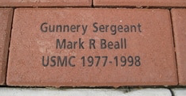 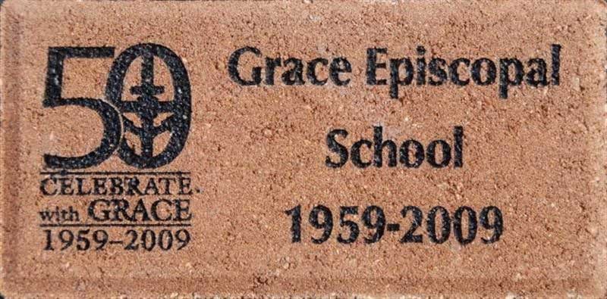

4” x 8” - **$65** with Clip Art

**$100 -** With Looping Computer Program –Honoree Picture, Honoree Bio and Clip Art.

|  |  |  |  |  |  |  |  |  |  |  |  |  |  |  |  |
| --- | --- | --- | --- | --- | --- | --- | --- | --- | --- | --- | --- | --- | --- | --- | --- |
| [Clip Art Number] |  |  |  |  |  |  |  |  |  |  |  |  |  |  |  |
|  |  |  |  |  |  |  |  |  |  |  |  |  |  |  |
|  |  |  |  |  |  |  |  |  |  |  |  |  |  |  |
|  |  |  |  |  |  |  |  |  |  |  |  |  |  |  |
|  |  |  |  |  |  |  |  |  |  |  |  |  |  |  |

For Looping Computer Program orders please complete Bio Section below (up to 4 lines) and Attach Honoree Picture. (Examples can be seen at the Hamblen House Post 37 Restaurant)